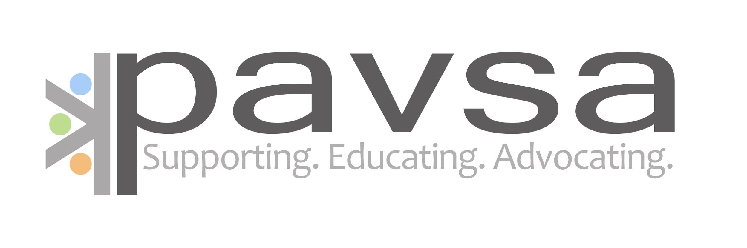
Volunteer Application

Name: _________________ Phone (H): _____________ Alt. Phone: _______________

Street Address: ___________. City: __________ State: ______ Zip code: ________

Email:___________________ Occupation: _____________________

Date of Birth:

Today's Date:

If Currently a Student, Please Document Year in School: ___________

Educational background:

_________________________________________________
Other organizations/groups affiliated with:
___________________________________________________________________________________________________________________________________________________________________________________________

1. Why would you like to be a volunteer with PAVSA?

_____________________________________________________________________________________

2. What is your definition of Sexual Assault?

_______________________________________________________________________________________

3. What are your beliefs/attitude towards individuals who have been sexually assaulted?

___________________________________________________________________________________

4. What is your comfort level talking about and working with issues of sexuality?

_________________________________________________________________________________

5. What is your experience and level of comfort working with/advocating for an individual who identifies as being part of the following communities/cultures? (Please respond to each one)

African American _________________________________________________________________________________
Native American __________________________________________________________________________________
Asian American ______________________________________________________________________________
Immigrant ___________________________________________________________________________________

Latinx _____________________________________________________________________________________
Vulnerable adults __________________________________________________________________________
LGBTQAI2 ____________________________________________________________________________________
Persons with developmental or physical disabilities ____________________________________________________________________________________________

Religious groups/faith communities _____________________________________________________________________

6. We work in the Building for Women which also houses the WE Health Center, an abortion provider. PAVSA advocates for the use of the Early Contraceptive Pill (High dosage of Birth Control Pills used to prevent pregnancy) with SV survivors if they choose to use this. Do you have any convictions regarding reproductive rights and PAVSA’s involvement?

_________________________________________________________________________________
7. Please rate your comfort level working with the following issues:

(Lowest comfort) 1 2 3 4 5 6 7 8 9 10 (Highest comfort)

Suicide          
Drug Abuse          
Mental Illness          
Alcohol          

8. How will you be supportive to persons affected by sexual assault who have values, views and/or lifestyles that are different from your own?

__________________________________________________________________________________________

9. Describe your strengths and things you struggle with:

_______________________________________________________________________________________
10. How do you avoid becoming over stressed? How do you take care of yourself?

___________________________________________________________________________________________

11. Have you had any special training (i.e., public speaking, communication skills, counseling, etc.) that would be relevant
to working in the area of sexual assault?
If YES, please describe:_______________________________________________________________

12. Are you available to attend all training sessions? (You can only miss 2 but they come with homework)

If NO, please explain. _______________________________________________________________________
___________________________________________________________________________________________
13. Do you have available transportation for hospital calls?___________________________
14. Do you anticipate any changes in your life in the next 8 months which could affect your involvement as a
PAVSA volunteer (we expect about a year commitment of taking at least one shift a month for a year
_________________________________________________________________________________
Please return completed application to:
PAVSA * Attn: Erin Naughton * 32 E First St. Suite 200* Duluth, MN 55802 or email to enaughton@pavsa.org

